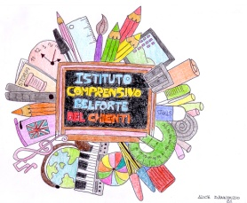
Istituto Comprensivo
ENNIO MORRICONE

Via Belforte del Chienti, 24 – 00156 Roma - ☎ 06 41217716
Codice fiscale: 97712620588 – Cod. meccanografico: RMIC8EQ00G
https://www.icbelfortedelchienti.edu.it
✉ RMIC8EQ00G@istruzione.it
pec: RMIC8EQ00G@pec.istruzione.it

COMMISSIONE: ___________________________
INCARICO: ___________________________
FS: ___________________________

BISOGNI RILEVATI :………………………………………………………………………………………………………………………………………………………………………………………………………………………………………………………………………………………………………………………………………………………………………………………………………………………………………
OBIETTIVI E RISULTATI ATTESI:
:………………………………………………………………………………………………………………………………………………………………………………………………………………………………………………………………………………………………………………………………………………………………………………………………………………………………………
:……………………………………………………………………………………………………………………………………………………………………………………………………………………………………………………………………………………………………………………………
AZIONI PREVISTE:
:………………………………………………………………………………………………………………………………………………………………………………………………………………………………………………………………………………………………………………………………………………………………………………………………………………………………………
:……………………………………………………………………………………………………………………………………………………………………………………………………………………………………………………………………………………………………………………………
VERIFICA E VALUTAZIONE
………………………………………………………………………………………………………………………………………………………………………………………………………………………………………………………………………………………………………………………………
:……………………………………………………………………………………………………………………………………………………………………………………………………………………………………………………………………………………………………………………………

FIRMA

………………………………

